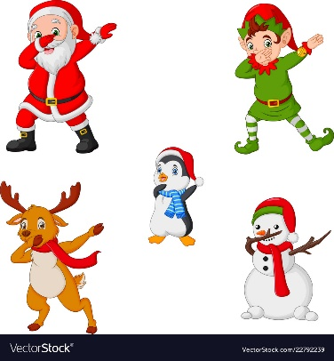

All I Want For Christmas is you
https://www.youtube.com/watch?v=1NDXEdNzn_w&feature=youtu.be
https://www.youtube.com/watch?v=8jn_f5tVhR8

Christmas Dance
https://www.youtube.com/watch?v=9qoRufKdXwU&feature=youtu.be

Santa Claus Is Comin' to Town
https://www.youtube.com/watch?v=_z7Kmn6-1oM&feature=youtu.be

Jingle Bell Rock"
https://www.youtube.com/watch?v=ltNPQ5bAvyc&feature=youtu.be

We wish you a Merry Christmas
https://youtu.be/-UY9XZe4mvE

Last christmas
https://www.youtube.com/watch?v=Ktm-Y_l-ftY

Merry Christmas Everyone

https://www.youtube.com/watch?v=i68yamm6Wto

