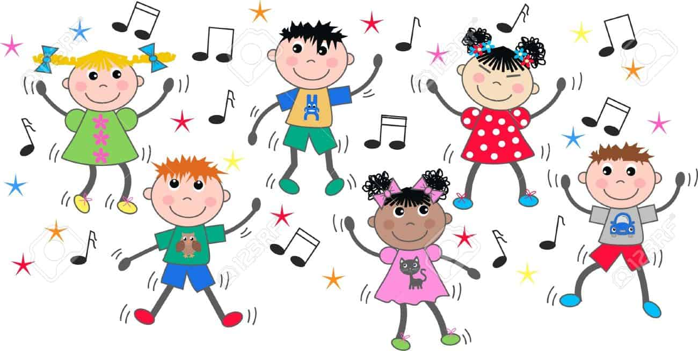

Mamma Mia by Abba
https://www.youtube.com/watch?v=rmUpvkGUBiY&feature=youtu.be

Dance Monkey
https://www.youtube.com/watch?v=7TGbssGDvIA&feature=youtu.be

Despacito
https://www.youtube.com/watch?v=HRPXVXPdV7k&feature=youtu.be

Baby Shark
https://www.youtube.com/watch?v=1mSjCS7WXQg&list=RDRwxVLFQR65A&index=3

